# CS 255 System Design Document

## UML Diagrams

### UML Use Case Diagram

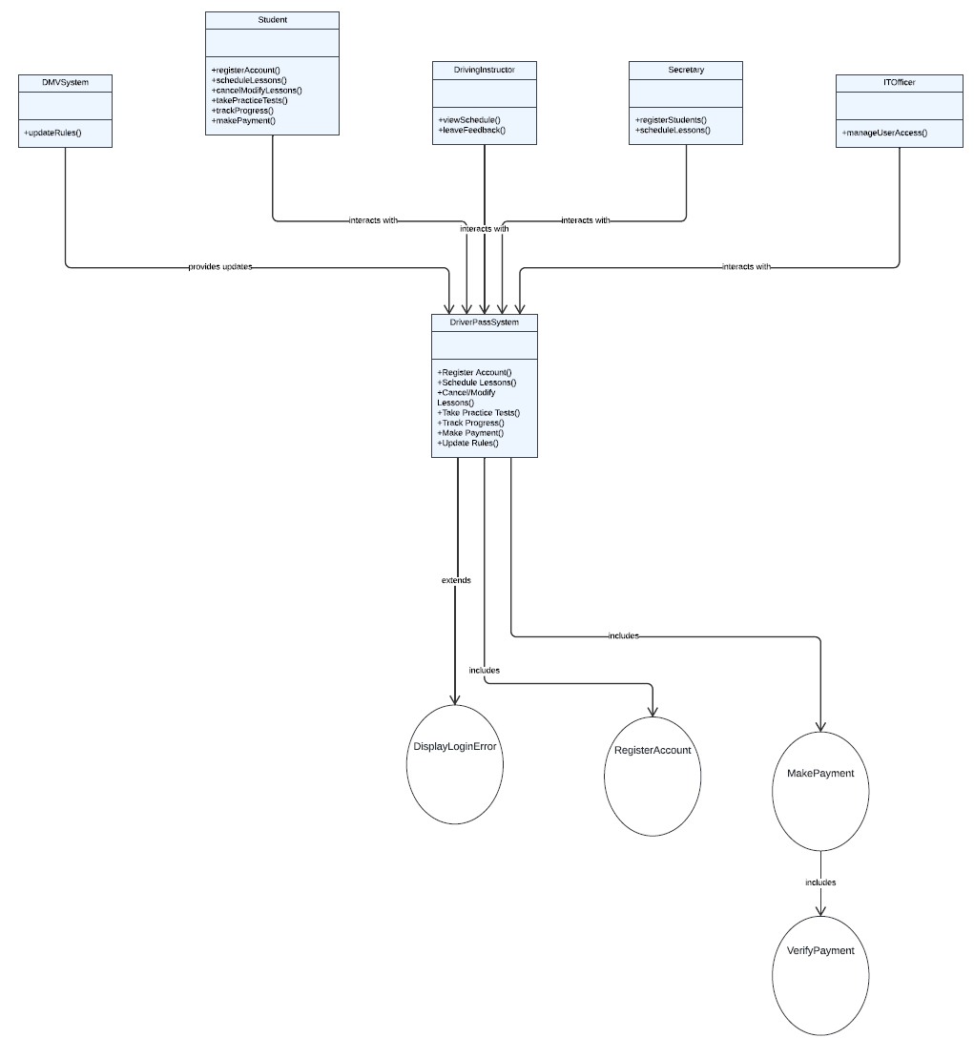

### UML Activity Diagrams

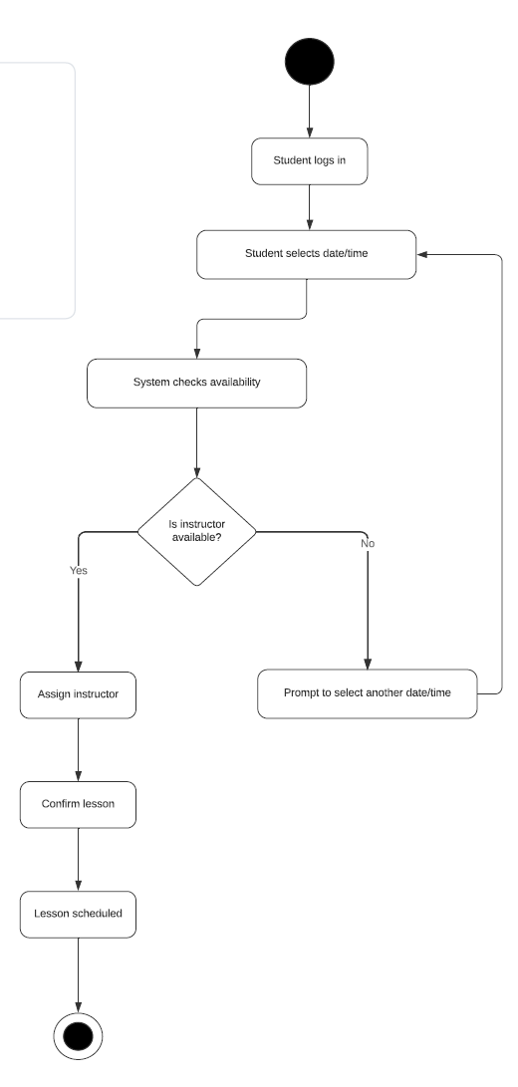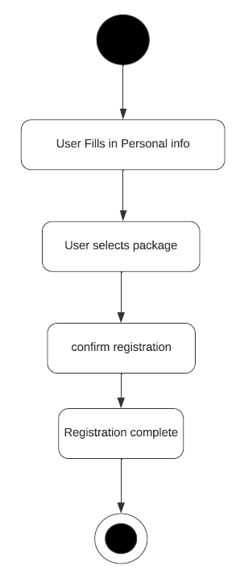

### UML Sequence Diagram

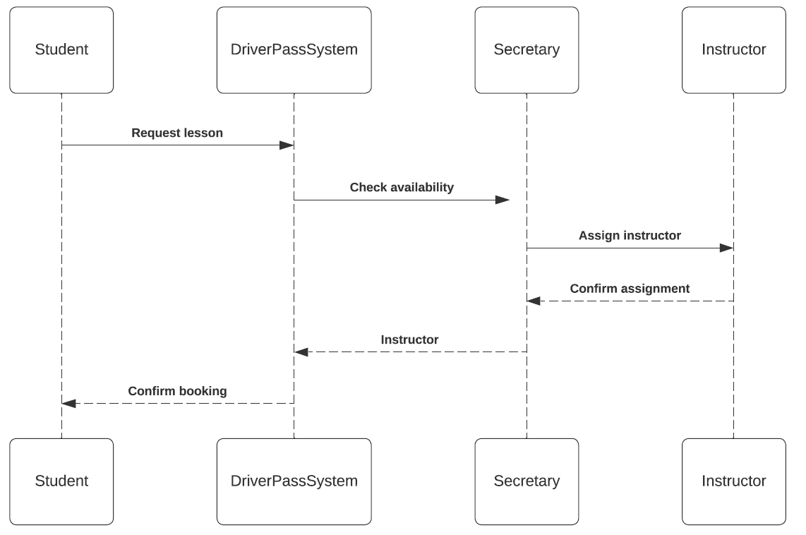

### UML Class Diagram

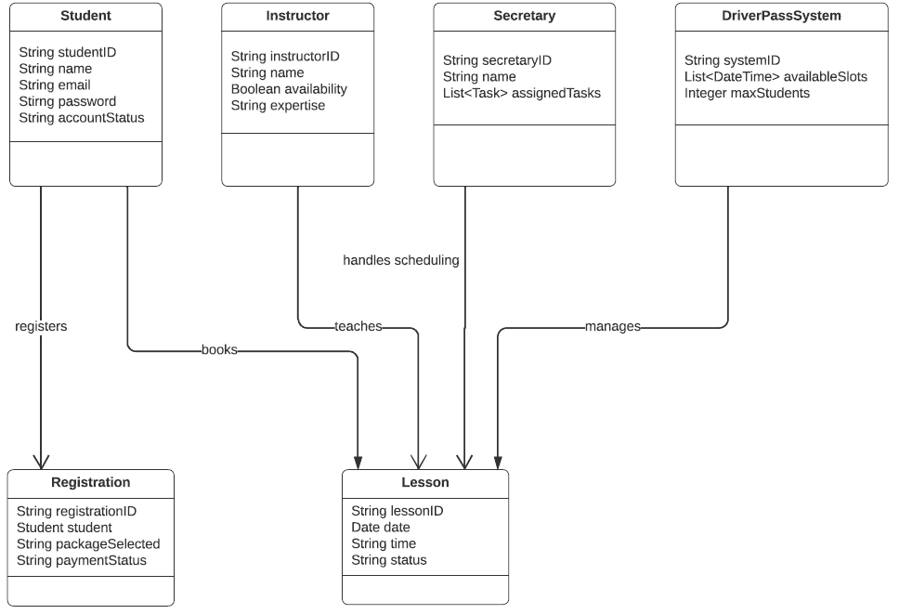

## Technical Requirements

**Hardware**:

* **Web Server**: Needed to host the online platform where students can register, schedule lessons, and take practice tests.
* **Database Server**: Required to store user data, lesson schedules, instructor availability, and other essential information.

**Software**:

* **Web Application**: A system that allows users (students, instructors, secretaries) to interact with the platform via their web browsers.
* **Database Management System (DBMS)**: Software to manage and store relational data, such as user profiles, lesson history, and booking information.
* **Payment Gateway**: Secure software to process payments when students register for lessons or packages.

**Tools**:

* **UML Design Tools**: Used for modeling and designing the system’s workflow and structure (e.g., Lucidchart).
* **Security Tools**: Tools to ensure secure communication, such as encryption for protecting user data (passwords, payment information).

**Infrastructure**:

* **Cloud Hosting or Local Servers**: The system will be hosted either in the cloud or on local servers, ensuring scalability and performance.
* **Backup and Redundancy**: Regular backups are required to prevent data loss and ensure system stability during high usage or in case of failures.